FPC Design specification for Manufacturing and Assembly

CONTENTS
I. Drilling holes design 1
II. Circuit Design 2
III. Solder mask design 4
IV. Screen printing design 5
V. Accessory design 5
VI. Outline Design 8
VII. Panel design 8

FPC design is similar to rigid PCB design, but the difference lies in the fact that FPC is relatively flexible, making it less convenient for assembly and soldering. Therefore, it is necessary to make local additions some rigid reinforcement. However, major EDA software do not have dedicated reinforcement layers, resulting in a wide variety of designed data,
Some use CAD to design reinforcement, some use image annotations, and some use annotations in Gerber files. PCB manufacturing engineers are prone to overlook reinforcement requirements or distort the information about reinforcement requirements, resulting in the production of unusable FPC.
To address this industry pain point, we have developed a design specification for FPC manufacturability. This guide aims to assist FPC design engineers in creating high-quality FPC designs that are highly manufacturable, easily assembleable, and cost-effective in terms of manufacturing costs and production time.

I. Drilling holes design
1. Requirements for leak inspection
(1) Metallized holes need to be designed in the DRL drilling layer file.
(2) The non-metallized holes need to be designed on the frame layer, and it must be ensured that there are no other messy elements on the frame layer.

2. Inspection of unreasonable via design
(1) The vias cannot be designed in a row, and they need to be staggered up and down or left and right.
(2) The via cannot be partially opened and partially covered with oil.
(3) The distance from the drill hole to the plate edge should be at least 0.5mm.

3. Design requirements for half-hole on board edge
Half-holes are typically designed on the solder pads near the board edges that require soldering, facilitating tin passing during soldering.
(1) It is recommended that the diameter of the via hole be no less than 0.3mm.
(2) The center of the half-hole should be designed at the exact center of the frame line.
(3) For soldering gold fingers, it is recommended to drill 2 vias on each pad, and the vias within the board should be staggered, rather than arranged in a row.
The half- hole-welded gold finger is shown as follow.
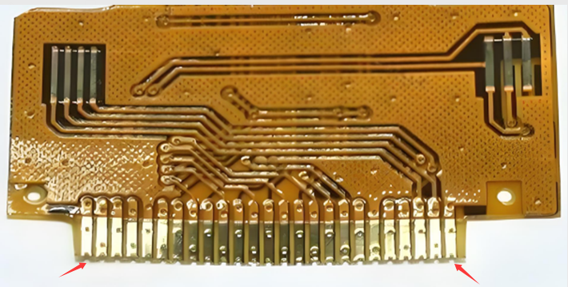

(4) For independent half-hole designs, it is recommended to use elliptical solder pads and ensure that the remaining width of the solder pads within the board is above 0.3mm.

II. Circuit Design
1. Design requirements to avoid solder pad detachment
(1) It is recommended to design the independent solder pad with solder mask (designed as an SMD solder pad, meaning the solder pad should be larger than the opening).
(2) The front and back solder pads cannot overlap, and their dimensions need to be staggered.
(3) The diameter of the BGA solder pad should not be less than 0.25mm.
(4) The plug-in hole area requires reinforcement, typically using FR-4 reinforcement.

2. Distance from the copper track to the board frame
(1) To avoid copper damage during molding, the normal distance for routing or copper plating to the board edge should be at least 0.2mm, and for boards with high voltage, it should be greater than 0.5mm .
(2) The width of the solder pad on the board edge needs to be at least 0.5mm, and please note in the order: the solder pad cannot be trimmed, otherwise it will be trimmed by default
The disc is 0.2mm away from the plate edge.
(3) When the board edge solder pads are not allowed to be trimmed, they need to be accepted with minor carbon powder issues or changed to die-cutting.

3. Circuit ground copper design
(1) Try to avoid laying copper over a large area, as this may lead to issues such as lamination bubbles and watermarking. If it is unavoidable, some breathable solder mask windows can be added on the ground copper.

(2) It is recommended to design the ground copper into a grid pattern with a line width of 0.2mm and a spacing of 0.2mm.

4. Pad-to-line design
(1) When the spacing between solder pads is less than 0.5mm, try not to route wires between the pads.
(2) A spacing of 0.2mm is required between the solder pad and the wire.

5. Design requirements for line width/line spacing
(1) Copper thickness 12μm (0.33oz): 3/3mil (limit 2/2mil).
(2) Copper thickness 18μm (0.5oz): 3.5/3.5mil (limit 3/3mil).
(3) Copper thickness 35μm (1oz): 4/4mil (limit 3.5/3.5mil).
Special circumstances:
(1) The line width of the open area needs to be increased by 1~2mil on the basis of the above.
(2) The line width/line spacing of the coil board should be designed to be at least 5/5mil.

6. Design requirements for through-hole pads
(1) The outer diameter of the via must be at least 0.2mm larger than its inner diameter.
(2) The outer diameter of the plug hole needs to be at least 0.4mm larger than the inner diameter.
Special circumstances:
(1) The outer diameter of the open area needs to be increased by 0.05~0.1mm based on the above.
(2) When the inner diameter of the hole is greater than or equal to 2.0mm, the outer diameter needs to be at least 0.6mm larger than the inner diameter.

7. Design requirements for FPC reverse gold finger
A reverse gold finger refers to a situation where one end of the gold finger is on the front side, while the other end is on the back side.
(1) It needs to be designed as a double-sided circuit, with the front and back circuits connected and layered through the addition of vias.
(2) When placing an order, it is necessary to select a double-layer board. If there is a need for gold finger insertion and extraction, PI reinforcement should be designed.

III. Solder mask design
1. Design requirements for solder mask bridges
Solder mask bridge refers to the solder mask between two solder pads. For FPC, the solder mask used is a cover film, and The distance between two solder pads needs to be at least 0.5mm to retain the solder bridge.

2. Requirements for the distance from the solder mask opening to the copper
(1) The distance from the solder mask opening to the copper should be above 0.15mm (i.e., there should be a distance of at least 0.2mm between the solder pad and the copper).
(2) When the spacing between two pads of small components such as capacitors, resistors, and LED lights is less than 0.5mm, there should be no copper on the middle.

3. Design of solder mask covering partial solder pads
An unreasonable FPC solder mask design can lead to easy fracture at the solder pad and trace junction. the solder mask covering part of the solder pad refers to the design where the circuit solder pad needs to be made larger so that the solder mask window can press down on a solder pad so that the solder mask window can cover a bit of the solder pad to prevent the solder pad from falling off or the junction between the solder pad and the circuit from breaking.
(1) The window openings for the cover films on the front and back of the soldered gold finger should be staggered by 0.3~0.5mm, and the window sizes on the front and back surfaces cannot be the same.
(2) The window edge should not be placed at the junction of the line and the pad, and a design with a pressed PAD is required.
(3) If it is not easy that do the design of solder mask cover part pad, it is recommended to use a substrate with a 50μm PI.

4. Design requirements for solder mask windowing
(1) For keypad solder mask opening, a window needs to be created.
(2) The length of solder mask openings should generally not exceed 20mm, and large-area openings should be avoided as much as possible.
(3) The solder mask window must be designed on the solder mask layer, not just on the steel mesh layer.
(4) Try to add more ventilation windows to the process scraps or the copper on the ground.
(5) Gold fingers and component solder pads must have solder mask windows. Large-area windows may cause wrinkling issues.

5. Solder mask window design for Via
(1) Conventional vias cannot be designed as plug-in via attributes in EDA software, and should be designed as Via attributes.
(2) For FPC via holes, we produce them with solder mask by default. If a window is required, special remarks are needed.
(3) If a via hole needs to be windowed, it cannot be designed as a Via attribute and special instructions must be provided when placing the order.
(4) For via-shaped test points, it is necessary to design the Testpoint attribute and provide a screenshot to illustrate the need for windowing.
(5) The via hole cannot be partially opened and partially covered with film. A safety clearance of at least 0.5mm needs to be maintained.

IV. Screen printing design
(1) The marking characters need to be designed on the outside of the board.
(2) The characters on the bottom layer need to be mirrored.
(3) Text cannot be designed on the solder pad.
(4) The text height is 1.0mm, and the character line width is 0.15mm.
(5) When there is a silk-screen requirement for reinforcement, please add memo .

V. Accessory design
1. Selection of reinforcement material
(1) PI reinforcement board is suitable for reinforcing the gold finger area of plug-in and unplug-in components.
(2) FR-4 reinforcement board is suitable for reinforcement in the plug-in hole area or for reinforcement on the back of low-end IC chips.
(3) Steel reinforcement plates are suitable for reinforcing the back of IC chips, BGA devices, etc., with good flatness, but hall elements and plug-in holes cannot be used.

2. Reinforcement marking
When designing reinforcement, it is necessary to clearly indicate the reinforcement material, thickness, layer, area, etc., and provide them when placing the order.

EDA software can indicate reinforcement information through a blank silkscreen layer or in the image, and specify the reinforcement when placing the order
The information is indicated at the specified location. The three essential elements of the reinforcement diagram are: material, thickness, and area, as follow photo.

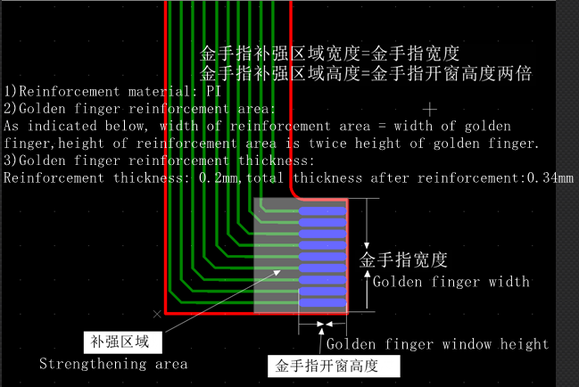

3. Reinforcement dimension design
(1) The reinforcement area needs to be at least 1.0mm larger than the solder pad to effectively prevent the junction between the solder pad and the circuit from breaking.
(2) The minimum width of FR-4 reinforcement board and 3M adhesive is 3mm.
(3) The minimum width of the PI reinforcement plate is 2mm.
(4) The minimum width of the steel sheet reinforcement plate is 1mm.

4. Calculation of PI reinforcement thickness for gold finger insertion and extraction
The gold finger board, when plugged in or removed, typically requires PI reinforcement on the back of the gold finger. After reinforcement, the total thickness of the FPC needs to match the thickness specified in the connector specification document.
(1) The thickness tolerance of the board at the gold finger is ±0.03mm.
(2) When calculating the PI reinforcement thickness, the FPC thickness needs to subtract the thickness of one layer of covering film and consider whether the circuit layer on the back of the gold finger is covered with copper.
.
(3) When placing an order for gold finger boards, be sure to specify the total thickness requirement for FPC+PI reinforcement.

5. Requirements for reinforcement and avoidance
Reinforcement avoidance refers to the situation where the reinforcement covers the solder pad or hole, and if the solder pad needs to be exposed, it is called a solder pad avoidance; If you only want to expose the hole without exposing the solder pad, it is called avoiding the hole.
(1) avoiding solder pad: The reinforcing opening is 0.3mm larger on one side than the solder mask, which may lead to issues between solder masks or from the solder mask to
There is no reinforcement between the plate edges.
(2) avoiding the hole: The reinforcement opening is only 0.1mm larger than the hole on one side. It is necessary to confirm whether the reinforcement covering the solder pad affects soldering.
(3) We usually default to using solder pads for avoidance, which may result in no reinforcement between solder pads or between solder pads and the board edge,if there are any special requirements, please make special notes.
(4) The reinforcement on the back of the solder pad for surface mounting should not be perforated, otherwise it will cause the solder pad to be concave.

6. SMT reinforcement design requirements
FPC can also undergo SMT like PCB, but when designing, try not to design reinforcement on the side with surface-mounted components, because
The reinforcement has a certain thickness, which can lead to uneven solder deposition during the printing of solder paste, making it impossible to attach components and inconvenient for maintenance.
(1) FR-4, steel sheet, PI, and other reinforcements, as well as 3M adhesive, should ideally not be applied to the side with components.
(2) Before SMT, the adhesive tape used should be 3M9077. After SMT, it is normal for the adhesive tape to bubble, shrink, or for the release paper to turn yellow,
It does not affect the quality.
(3) No reinforcement can be designed between the two sets of pins on the chip.
(4) If reinforcement is necessary on the component side, it is recommended to avoid the component casing during reinforcement, and to specify in the order: after SMT
Apply reinforcement, and accept the use of 3M adhesive for reinforcement.
7. Special reinforcement requirements
FPC auxiliary materials have many special requirements that need to be clearly marked, and the order needs to be noted with specific details as follows.
(1) 3M adhesive has specific tear-off position requirements.
(2) Half of the reinforcement requires adhesive removal (at the handheld position of the reinforcement tape).
(3) Adhesive is required for reinforcement.
(4) Both sides of the same location require reinforcement.
(5) The two types of reinforcement are additive.
The above special requirements are relatively troublesome in production, so try not to design them, otherwise it will increase costs.
8. Design requirements for electromagnetic film
The electromagnetic film is used to shield electromagnetic interference, with a thickness of 18μm and a black color. Adding an electromagnetic film will reduce impedance around 20Ω. If the interference is not particularly significant, it is recommended to use with caution. If the impedance control is not well managed, it may adversely affect the signal.
(1) Electromagnetic films generally require grounding. Failure to ground them will result in the absorption of a large amount of electromagnetic waves, leading to abnormal signal transmission.
(2) Electromagnetic film grounding refers to adding at least two solder mask windows with a diameter of 1.0mm or larger on the solder mask window corresponding to the ground copper.
(3) The electromagnetic film is a conductor, and it needs to be at least 0.5mm away from the solder pad.
(4) If electromagnetic film is applied locally, the area to be applied needs to be clearly marked.

VI. Outline Design
The shape refers to the final shape of the FPC that needs to be cut, including the outer frame and inner slot of the board. FPC samples and small batches are cutted by laser , theoretically, there are no restrictions on the shape design, but the following points should be noted.
(1) The appearance layer must be unique, generally represented by GM1 or GKO, and only one of the two can be retained.
(2) The frame lines of non-metallized hole rings or slots within the board should also be placed on the outline layer.

(3) No miscellaneous wires can be placed on the outer layer.
(4) The FPC shape must not have internal right angles or sharp corners, and it must be closed and not disconnected.
(5) If the FPC width is less than 2mm, it will roll up after cutting and requires micro-adhesive fixation for shipment. Additionally, carbon may be present
Phenomenon of powder residue.
(6) The distance between the solder pad and the outline should not be less than 0.2mm; otherwise, the issue of laser toner may need to be addressed or the design may need to be modified to accommodate die-cutting.

VII. Panel design
1. FPC panel design requirements
(1) The width should be designed to be either 120mm or 250mm, preferably an even number, to facilitate mold making.
(2) Panel spacing: The spacing between panels is generally 2mm. For panels reinforced with steel sheets, the spacing is recommended to be 3mm
Be consistent.
(3) FPC does not support stamp holes and V-cutting processes. FPC panels are connected using connection points with a width of about 0.8mm,
Except for the connection points, all other shapes are cut open using tangential lines. Customers can use a blade to separate the connection points or
The method of manual tearing is used for board separation. If manual tearing is adopted for board separation, it is recommended to add anti-tear lines.
(4) The width of the process edge is 5mm, and it should be added to all four sides normally. If no process edge is needed, please specify when placing the order.
(5) The maximum size of the panel is 250mmx600mm, and the minimum size is 70mmx70mm.
(6) The process edge needs to have positioning holes and Mark points.
(7) Try not to assemble two different boards together, as this may affect the efficiency of chip placement.

2. Anti-tear seam design
Anti tear wire refers to adding a small copper wire to the corresponding circuit layer at the connection point to prevent tearing of the board during splitting. Because the anti tear line is added at the line layer, it is necessary to evaluate whether it has an impact on the original line. If you need our help to add tear resistant lines, please make a note when placing the order and confirm if the positions added in the production draft are acceptable, Anti-tear line show as follow .

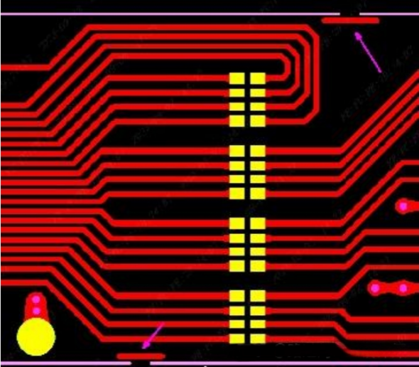

3. Connection point design
The width of FPC connection points should be determined based on the board size, whether SMT is applied, and whether there is a steel sheet or thick FR-4 present.
(1) The width of the board connection points for SMT is generally designed to be 0.8mm, and the connection points cannot be placed on half-holes or gold finger pads.
(2) The width of non-SMT board connection points is generally designed to be 0.25~0.3mm, with an addition of 2~3 connection points per PCS (It's best to make a note when ordering)
(3) If there are no special requirements for the connection points, we can assist in adding them.

4. Design requirements for small-sized boards
When the individual board size is relatively small, production on the assembly line can be cumbersome. It is recommended to make it as panel .
(1) The minimum size requirement for FPC+SMT boards is 70mmx70mm. If it is smaller than this value, panel splicing or adding process edges is required to reach this size.
(2) For boards with dimensions smaller than 50mmx50mm, it is recommended to produce them as panel boards. For irregular-shaped boards, you can request us to assist in making panel boards when placing your order.
(3) For items with dimensions less than 10mm x 10mm, they must be assembled into a panel or shipped with micro-coating.

